**AUTOMATION SELENIUM IDE**

**CLASS EXERCISE**

**Class Exercise 1:**

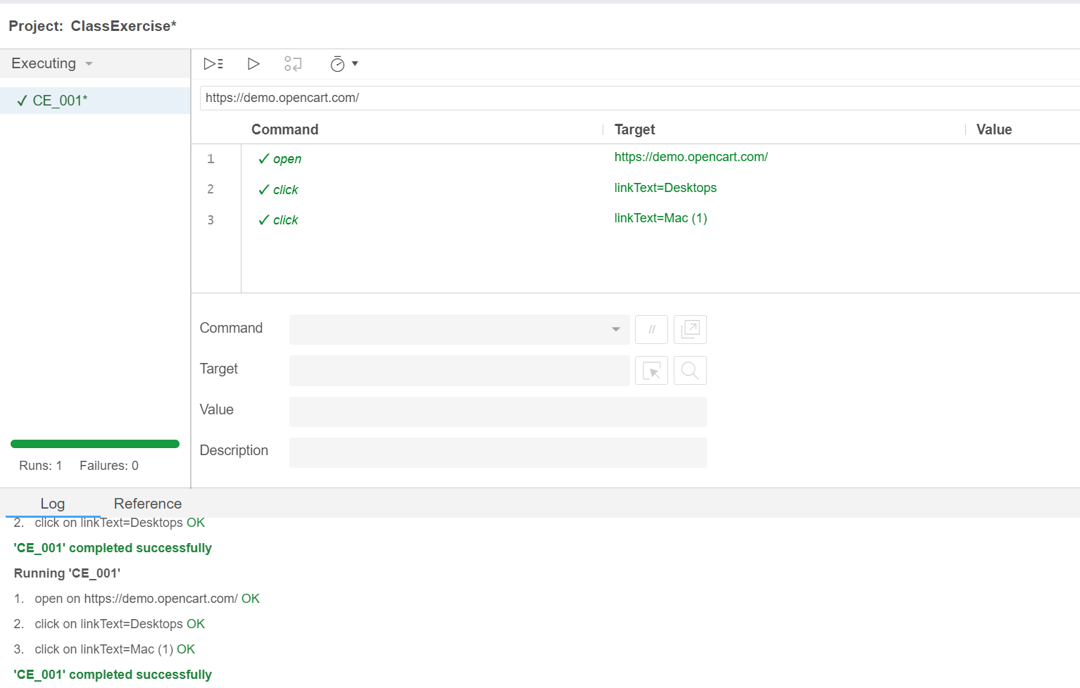

**Class Exercise 2:**

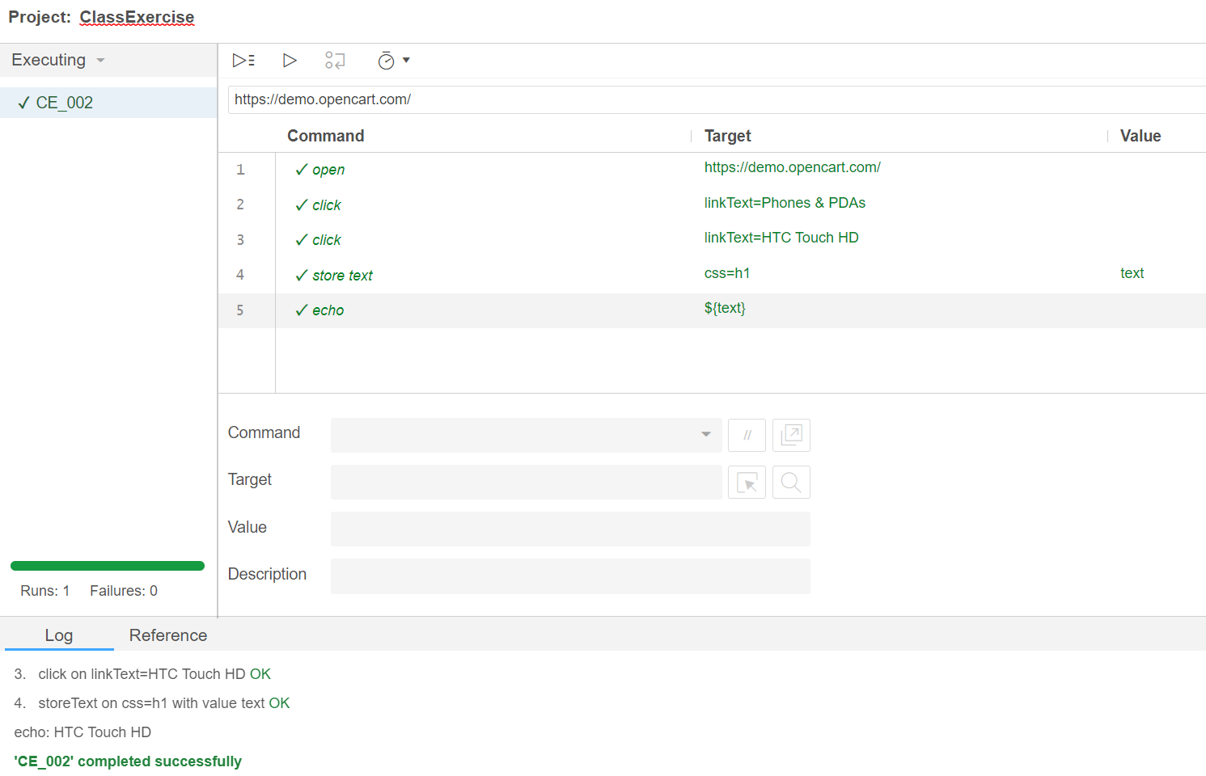

**Class Exercise 3:**

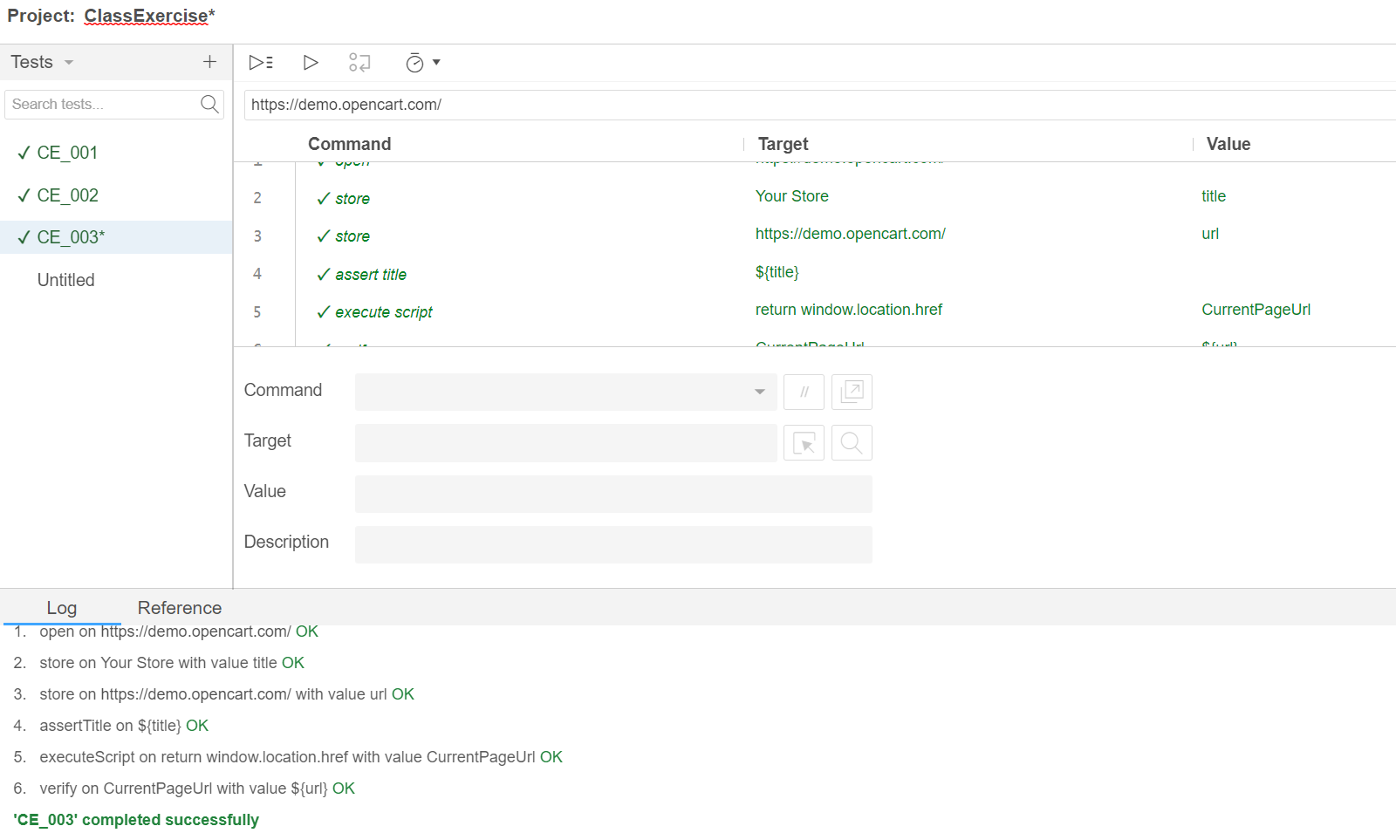

**Class Exercise 4:**

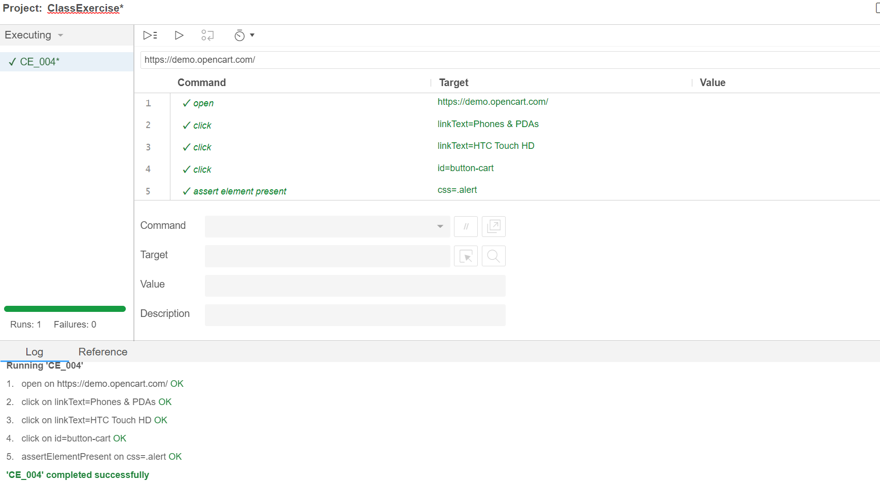

**Class Exercise 5:**

